Prompts in LangChain
https://www.youtube.com/watch?v=3TGqlQxpuU0&list=PLKnIA16_RmvaTbihpo4MtzVm4XOQa0ER0&index=6
campusx-official/langchain-prompts: Code related to my LangChain playlist
00:00 – Intro
01:00 – Recap
02:17 - Error Correction
06:17 – Prompts
10:30 - Static vs Dynamic Prompt
27:05 - Prompt Template
36:49 – Messages
56:31 - Chat Prompt Templates
01:06:37 - Message Placeholder
1. Introduction to Prompts in LangChain
In this video, the focus shifts to the second core component of LangChain: Prompts.
While prompts may look simple at first glance, they are one of the most sensitive and powerful levers in any Generative AI system.
The goal of the session is not just to explain what prompts are, but:
- Why prompts are needed
- Why naïve prompt usage fails in real-world applications
- How LangChain helps structure prompts professionally

2. Recap of Previous Videos (Context Setting)
Before diving into prompts, a brief recap helps establish continuity:
- Video 1:
Introduction to LangChain and why a framework is required to build GenAI applications.
- Video 2:
Overview of LangChain’s six core components with real-life analogies.
- Video 3:
Deep dive into the Models component, including LLM configuration and parameters.
This video builds directly on the Models component, because prompts are the inputs that drive model behavior.

3. Error Correction: Understanding Temperature Correctly
A correction is made to a common misunderstanding around the temperature parameter in LLMs.
Correct Interpretation of Temperature
- Temperature = 0 (or near 0)
  - Same input → same output every time
  - Deterministic behavior
  - Best for production systems requiring consistency
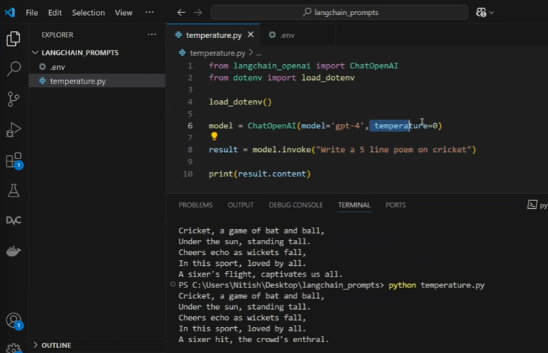
- Higher temperature (e.g., 1.0 – 1.5+)
  - Same input → different outputs
  - More creative, diverse responses
  - Useful for ideation, storytelling, brainstorming
Industry Perspective
- Customer support bots → Low temperature
- Marketing copy / creative writing tools → Higher temperature
- Compliance, legal, medical summaries → Temperature close to 0
This correction is important because prompt design and temperature work together to control output quality.

4. What Are Prompts?
A prompt is any input sent to an LLM to guide its response.
Prompts are not new—you’ve already been using them implicitly:
- “Write a five-line poem on cricket”
- “Summarize this research paper”
- “Explain this code”
In LangChain terminology, these inputs are explicitly treated as Prompts.

5. Types of Prompts: Text vs Multimodal
Prompts can exist in multiple formats:
Text Based Prompts:
- Text (most common today)
Multi-model prompts:
- Images
- Audio
- Video
This video focuses only on text-based prompts, because:
- They account for ~99% of current industry use
- Most LangChain tooling is optimized for text prompts today

6. Why Prompts Are Extremely Important
LLMs are highly sensitive to prompts:
- Small wording changes can cause large output differences
- Prompt quality directly impacts correctness, tone, and structure
Because of this sensitivity:
- Prompt design has evolved into a specialized skill
- A new role has emerged: Prompt Engineering
In LangChain, prompts are treated as first-class citizens, not just strings.

Static vs Dynamic prompts
7. Static Prompts: What They Are
A static prompt is when:
- The entire prompt is written manually
- The user has full control over wording
- The system directly forwards user input to the LLM
Example:
“Summarize the Attention Is All You Need paper in simple terms.”
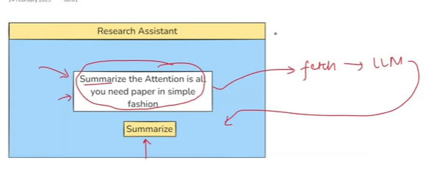
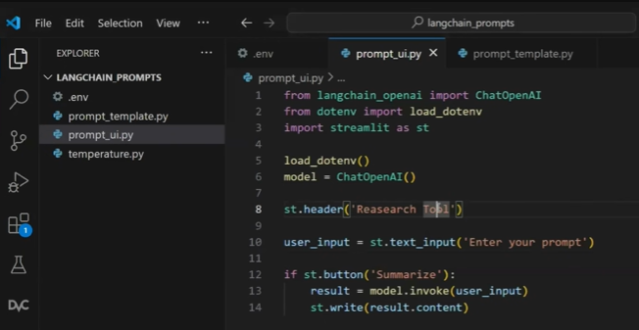

Whatever input we provide in “Enter your prompt” is treated as the user input, and it acts as a static prompt initially. Later, the user can also ask the system to summarize other papers as well.
Why Static Prompts Are Problematic
Here we are giving lot of control to user
- Users may:
  - Misspell paper names
  - Ask vague or contradictory things
  - Change tone, length, or style unpredictably
- Output becomes inconsistent
- Risk of hallucination increases

8. Industry Problem with Static Prompts
In real-world applications:
- You cannot trust users to write correct prompts
- You must guarantee consistency across users
Examples:
- Research assistant tools
- Legal document summarizers
- Enterprise internal knowledge bots
Static prompts break:
- UX consistency
- Reliability
- Safety expectations

9. Dynamic Prompts: The Core Solution
A dynamic prompt uses:
- A predefined prompt template
- Controlled placeholders
- Limited user input options
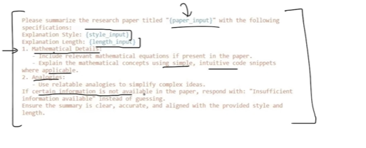
Instead of letting users write the full prompt:
- Users select values (paper name, style, length) using the dropdown
- The system fills a structured template
- The final prompt is generated programmatically
Importing the libraries remains same as that of the static prompting
We are asking three inputs from the user – paper_input, stype_input and length__input using the dropdown
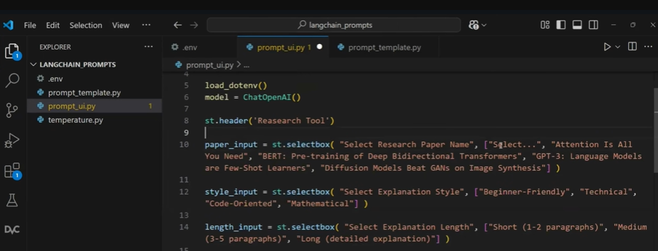
//For now for st.write() we have passed “hello” later it will be replaced
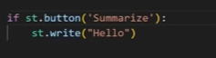
Now the UI looks like below
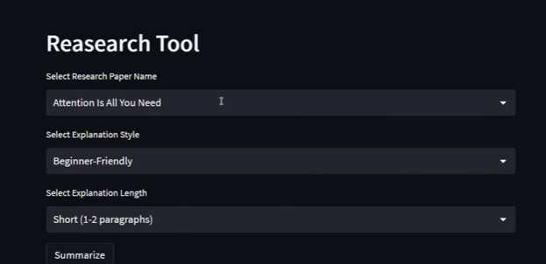

10. Prompt Templates in LangChain
We will import the PromptTemplate
We will create the template
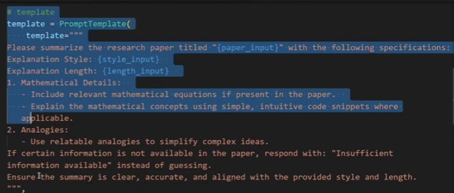
We create input variables to receive user input, and these variables are assigned the values provided by the user.
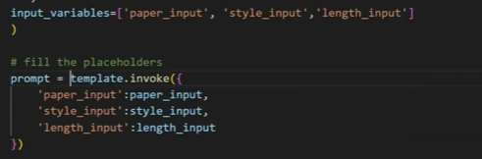
We will invoke the model by passing the prompt
Print() – will print in the console
To write it in the UI – st.write(result.content)
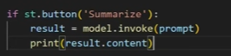
LangChain provides PromptTemplate to formalize prompt design.
A prompt template:
- Defines fixed instructions
- Defines placeholders for user-controlled variables
- Ensures consistent structure every time
Example placeholders:
- Paper title
- Explanation style (simple / math-heavy / code-heavy)
- Output length (short / medium / long)
This balances:
- Flexibility for users
- Control for developers

11. Why Dynamic Prompts Are Industry-Standard
Dynamic prompts solve:
- Hallucination risks
- Inconsistent tone and format
- User mistakes
- Poor UX
Industry Usage Examples
- Research tools: Controlled summaries with math + intuition
- Education platforms: Same explanation style for all students
- Enterprise AI tools: Predictable and auditable outputs
Almost all production GenAI systems use dynamic prompts, not raw user prompts.

12. UI-Driven Prompt Engineering (Streamlit Example)
The video demonstrates:
- Collecting user inputs via dropdowns
- Preventing free-text errors
- Mapping UI inputs to prompt variables
This pattern is extremely common in industry:
- Dropdowns instead of text
- Checkboxes instead of sentences
- Sliders instead of vague descriptions
This is prompt engineering + UX design combined.

13. How LangChain Executes Dynamic Prompts
The flow is:
- User selects controlled inputs
- Inputs are injected into a prompt template
- Template is converted into a final prompt
- Prompt is sent to the LLM
- Output is displayed to the user
This separation makes systems:
- Easier to debug
- Easier to improve
- Easier to scale

14. Real-World Industry Perspective (Where It Truly Matters)
Where This Is Used
- AI-powered research assistants
- Internal enterprise copilots
- Financial report summarizers
- Compliance and audit tools
- Education platforms
Why Companies Care
- Consistency across thousands of users
- Reduced hallucination risk
- Predictable output formats
- Easier governance and review

15. Project Ideas (Relevant and Practical)
Project 1: Research Paper Assistant (Intermediate)
- Dropdown for paper selection
- Dropdown for explanation style
- Dropdown for summary length
- Dynamic prompt template
- Output shown in structured format
Project 2: Enterprise Knowledge Summarizer
- Fixed internal documents
- Users choose tone (executive / technical)
- Dynamic prompts ensure compliance-safe output
Project 3: Learning Companion Tool
- Same content explained differently for:
  - Beginner
  - Intermediate
  - Advanced learners
- Single prompt template, multiple styles

17. PromptTemplate vs f-Strings (Revisited with Practical Proof)
When learning PromptTemplate for the first time, a very natural doubt arises:
“Why can’t we just use Python f-strings instead?”
At a surface level, both do the same thing:
- Create a large string
- Insert dynamic placeholders
- Pass values at runtime
And yes — the same code can be written using f-strings and it will work.
So why does LangChain introduce a separate PromptTemplate class?
There are three strong, practical reasons, which become very clear when you see real code behavior.
  - Automatic Validation
  - Prompt reusability and clean code structure
  - Native compatibility with langchain ecosystem

18. Benefit 1: Automatic Validation (Fail Fast, Not in Production)
When you use PromptTemplate, LangChain can automatically validate:
- All placeholders used in the template
- All variables passed during invocation
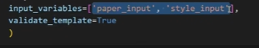
Adding extra input_variable which is not present in the template
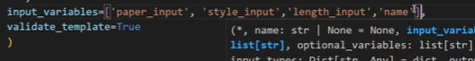
Example Scenario
Assume your template uses:
- style
- input
- length
If you:
- forget to pass length, or
- pass an extra variable not used in the template
LangChain throws an immediate error during development.
This is controlled using:
- validate_template=True
Why This Matters in Industry
In real applications:
- prompts are dynamic
- values often come from APIs, forms, or pipelines
- silent prompt errors cause incorrect LLM behavior
PromptTemplate ensures:
- errors appear during development
- not after deployment
f-strings offer zero validation — mistakes surface only at runtime.

19. Benefit 2: Prompt Reusability and Clean Code Structure
In small demos, prompts look manageable.
In real systems, prompts:
- are very large
- are shared across multiple files
- are reused across multiple pages or services
Embedding large prompts directly inside code:
- makes files bulky
- reduces readability
- makes maintenance painful
PromptTemplate Solution
LangChain allows you to:
- save PromptTemplates as JSON files
- load them whenever required
- reuse the same prompt across multiple applications
What This Enables
- Prompt logic is separated from application logic
- Prompts can be versioned
- Teams can update prompts without touching core code
Whatever prompt template we have written should be cut and pasted into prompt_generator.py, which is used exclusively for storing the prompts.
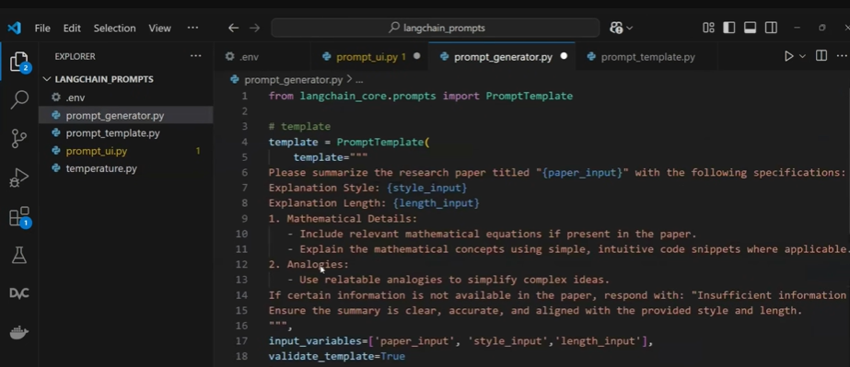
We will save this template – we will save it as template.json
When we run this file – a new file template.json will get created
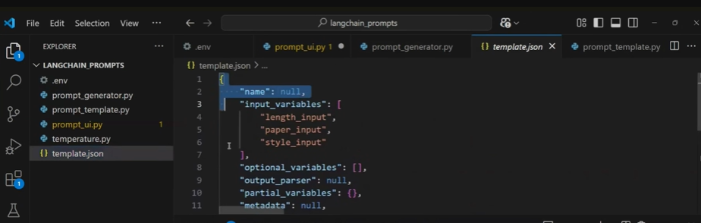
To load it wherever requires
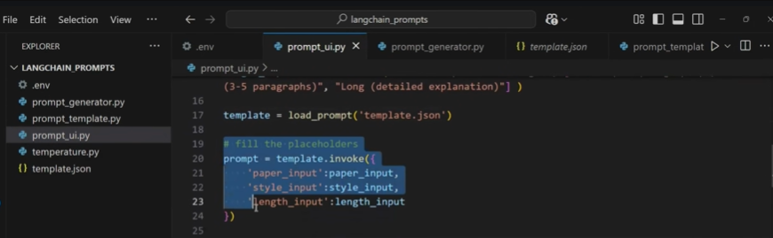
It helps in reusability – we can reuse it wherever required
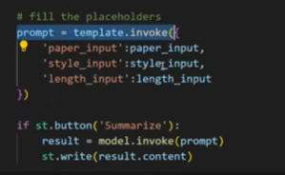
In the above code we can see that we are calling invoke () function 2 times instead we can call only once by using chains
Prompts and chains both are the components which uses the invoke() method
We will create chain using template and model
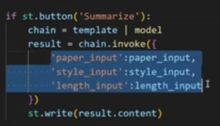
Industry Perspective
In production GenAI systems:
- prompts are treated like configuration
- prompt engineers and developers often work independently
- updates happen frequently
This separation is not practical with f-strings.

20. Benefit 3: Native Compatibility with LangChain Ecosystem
PromptTemplate is deeply integrated with:
- Chains
- Models
- Agents
- Memory
- RAG pipelines
The Problem Without PromptTemplate
If you use f-strings:
- you must manually format the prompt
- then manually call the model
- you cannot directly plug the prompt into a Chain
The Advantage with PromptTemplate
You can:
- combine PromptTemplate + Model
- form a Chain
- invoke everything with a single call
This simplifies:
- orchestration
- debugging
- pipeline readability
This is not possible with plain f-strings.

21. Key Conclusion on PromptTemplate
You can use f-strings.
But you should use PromptTemplate because it provides:
- validation
- reusability
- ecosystem integration
- scalability
This is why PromptTemplate is the recommended, industry-grade approach.

22. Building a Simple Console-Based Chatbot
Whatever chatbot we are building is the console chatbot and it looks like below:
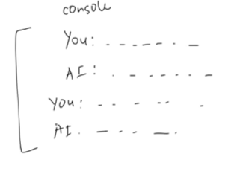
Now that prompts are clear, the next step is building a chatbot.
To keep things simple:
- no GUI
- no frontend
- chatbot runs entirely in the console
Chat Flow
- User types a message
- AI responds
- Conversation continues
- User types exit to stop
This is enough to understand core chatbot logic.

23. First Chatbot Implementation (Without Memory)
The initial chatbot:
- runs inside an infinite loop
- takes user input
- sends input directly to the LLM
- prints the response
This works, but introduces a serious limitation.
We will import ChatOpenAI and continuously take input from the user using a while loop.
If the user enters a valid input, we will send it to the model by invoking it.
If the user enters “exit”, we will break out of the loop.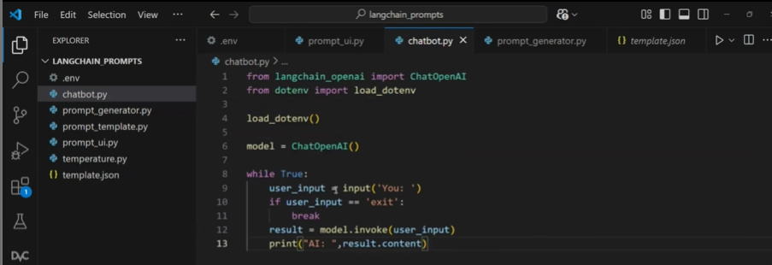

24. The Core Problem: No Context Awareness
Example conversation:
- User: Which number is greater, 2 or 0?
- User: Multiply the bigger number by 10
The chatbot fails because:
- it does not remember the previous message
- it does not know what “bigger number” refers to
Root Cause
Each request is treated as:
- independent
- stateless
- context-free
This makes the chatbot unreliable.

25. Naive Fix: Storing Chat History as a List
A simple improvement:
- store all messages in a list
- send the entire chat history to the LLM
We will create the list Chat_history and we will talk with the llm and we will append everything in the Chat_history list – The question that we ask to llm and the answer we get from the llm
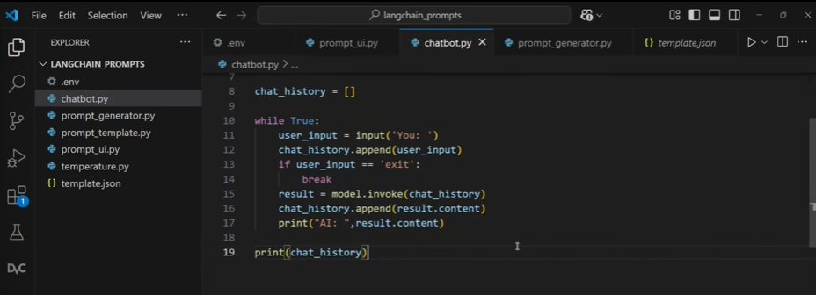
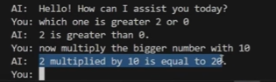
This restores context, but introduces another problem.

26. New Problem: No Information About Message Roles
If chat history is stored as plain text:
- the model does not know:
  - which message was from the user
  - which message was from the AI
As chat grows:
- confusion increases
- response quality drops
- hallucinations become more likely
This is not acceptable for real-world chatbots.
Ideally, we should not store only the chat history; we also need to store who sent each message, whether it was the user or the AI. – we should maintain the dictionary basically who is telling and what is the message – In this we need to maintain the dictionary
LangChain has solved this problem using the build in libraries
27. Industry-Grade Solution: Message Role Labeling
LangChain solves this problem using explicit message types.
There are three message types:
System Message
- Sets rules and behavior
- Sent once at the start
- Example:
  - “You are a helpful AI assistant”
  - System message is the one which we send during the beginning of the conversation
Human Message
- User’s input
- Human Message is something that human sends to llm
- Ex: what is the capital of France?
AI Message
- Model’s response
Each message is clearly labeled, so the LLM always knows:
- who said what
- in what order
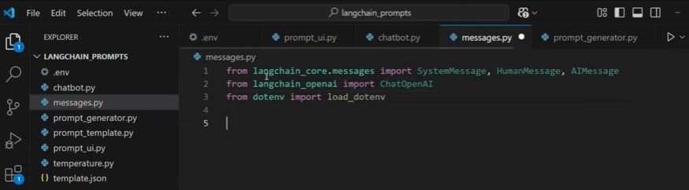
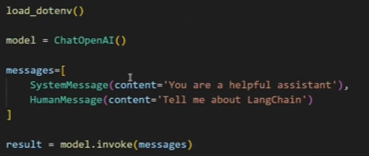
Whatever result we get from the model we convert it into AIMessage
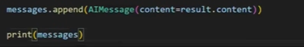
We get the system message, AI message and Human message in the output
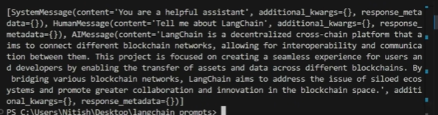

28. Why Message Roles Are Critical in Production
Industry Use Cases
- Customer support chatbots
- AI tutors
- Coding assistants
- Enterprise internal bots
All require:
- long conversations
- consistent behavior
- correct context interpretation
Without role-labeled messages:
- chat quality degrades
- logic breaks
- trust is lost

29. Implementing Messages in the Chatbot
Updated chatbot flow:
- Start chat history with a SystemMessage
- Convert user input → HumanMessage
- Send entire message list to the LLM
- Convert response → AIMessage
- Append back to chat history
Now the chatbot:
- understands context
- tracks conversation correctly
- behaves consistently
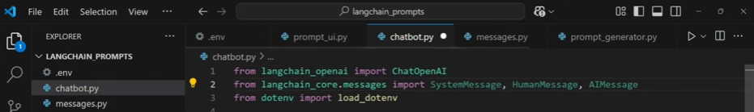
Create the system message
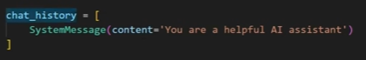
We will convert the input into human Message and append it into chat_history now the message is going with the label
Result is also converted it into ai message
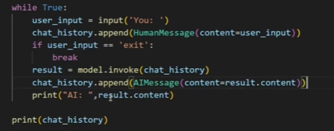

30. Final Outcome: A Context-Aware Chatbot
After introducing message roles:
- the chatbot correctly handles follow-up questions
- previous context is preserved
- large conversations remain stable
This is the foundation of every real GenAI chat application.

31. Key Takeaways from This Section
- PromptTemplate is essential for scalable GenAI apps
- Validation, reuse, and chaining are its biggest strengths
- Naive chatbots fail due to lack of memory
- Storing chat history alone is not enough
- Message role labeling is mandatory
- LangChain’s System, Human, and AI messages solve this cleanly

32. Recap: Ways to Invoke an LLM
Before introducing Chat Prompt Templates, it’s important to recap how we interact with LLMs.
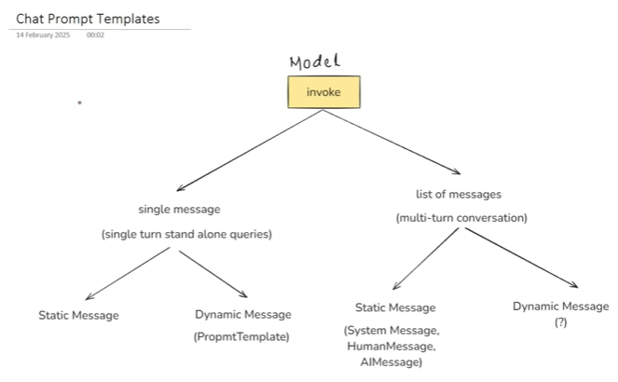
There are two ways to invoke an LLM:
1. Sending a Single Message
This approach is used for:
- Single-turn
- Standalone queries
Examples:
- Upload a research paper → generate summary
- Ask a factual question → get one response
Here, the conversation starts and ends in one request.
Single messages can be:
- Static (hardcoded text)
- Dynamic (using PromptTemplate)

2. Sending a List of Messages
This approach is used for:
- Multi-turn conversations
- Chatbots
- Conversational assistants
Here, the LLM receives:
- System messages
- Human messages
- AI messages (chat history)
This is what enables context-aware conversations.

33. Limitation So Far: Only Static Messages in Chats
Up to this point:
- We learned how to send lists of messages
- We learned how to send dynamic single messages
But we did not yet learn how to:
- Make messages inside a list dynamic
This is exactly the gap that Chat Prompt Templates solve.
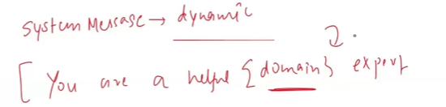
This is the dynamic system message where we don’t tell before in which domain the person is expert similarly the human message can also be dynamic
Explain about {topic}
Topic will be given by user

34. What Is a Chat Prompt Template?
A Chat Prompt Template is used when:
- You are sending a list of messages
- And those messages need placeholders
- And values must be filled at runtime
In simple terms:
- PromptTemplate → dynamic single message
- ChatPromptTemplate → dynamic list of messages
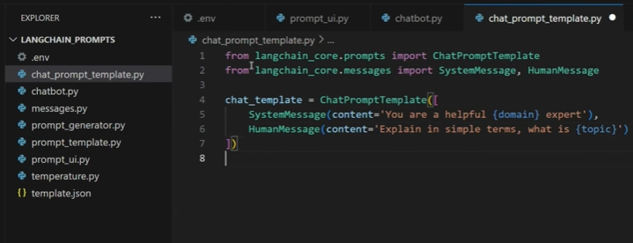
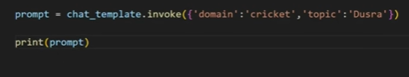
By running the file we get the problem here The placeholders are not properly filled

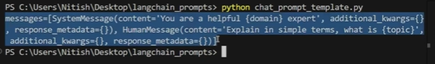
We will pass the tuple
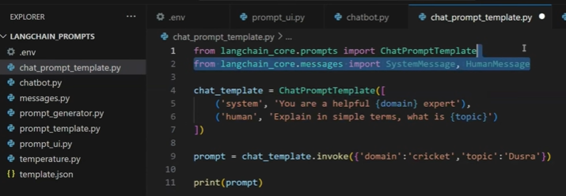
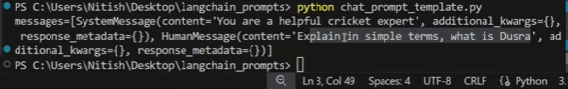

35. Why Do We Need Dynamic Messages in Chat?
Consider this example:
Dynamic System Message
Instead of hardcoding:
“You are a helpful cricket expert”
You want:
“You are a helpful {domain} expert”
The domain (cricket, finance, healthcare, law) should be decided at runtime.

Dynamic Human Message
Instead of hardcoding:
“Explain what is offside in cricket”
You want:
“Explain in simple terms what is {topic}”
The topic comes from the user.
Since:
- both system message
- and human message
are dynamic, ChatPromptTemplate is mandatory.

36. Creating a Chat Prompt Template (Conceptual Flow)
To create a chat prompt template:
- Import ChatPromptTemplate
- Define a list of messages
- Add placeholders inside message content
- Invoke the template with a dictionary of values
At invocation time:
- placeholders get replaced
- a final list of messages is produced
- that list is sent to the LLM

37. Important LangChain Behavior (Weird but Real)
When using ChatPromptTemplate, LangChain has a non-obvious behavior:
Using classes like:
- SystemMessage
- HumanMessage
directly inside the template does not fill placeholders.
This is confusing, but it’s a known limitation because:
- LangChain is still evolving
- some APIs behave differently across versions

38. Correct Way to Define Messages in Chat Prompt Template
Instead of using message classes directly, messages should be defined as:
- A tuple
  - First element → role (system, human)
  - Second element → template string with placeholders
This format ensures:
- placeholders are correctly replaced
- the template works as expected
LangChain documentation now recommends this approach.

39. Key Rule to Remember
- Use PromptTemplate → single-turn, single message
- Use ChatPromptTemplate → multi-turn, list of messages
- Use tuple-based message definitions for reliability

40. What Problem Is Still Unsolved?
Even with Chat Prompt Templates:
- we can create dynamic messages
- but we still cannot inject entire chat history dynamically
That is a major requirement for real-world chatbots.
This leads us to the next concept.

41. What Is a Message Placeholder?
A Message Placeholder is a special placeholder used inside a Chat Prompt Template to dynamically insert:
- Previous chat history
- A list of messages
- At runtime
It is specifically designed for:
- conversational memory
- session continuity

42. Why Message Placeholder Is Necessary (Industry Example)
Customer Support Scenario
A user:
- Requests a refund
- Gets confirmation
- Comes back after 2 days asking:
“Where is my refund?”
If the chatbot does not know:
- previous order ID
- previous refund confirmation
It cannot answer correctly.
So:
- past conversation must be stored
- retrieved
- injected into the new prompt
This is exactly what Message Placeholder enables.

43. Typical Industry Architecture Using Message Placeholder
- User chats with chatbot
- Messages are stored in:
  - database
  - cloud storage
  - cache
  - For now we are storing in one text file
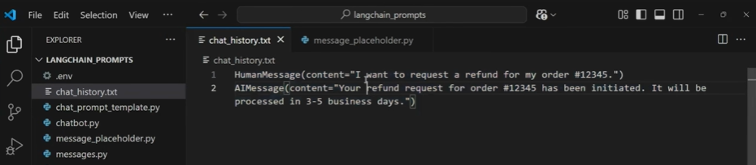
- When a new session starts:
  - old messages are loaded
- Loaded messages are injected using:
  - Message Placeholder
- New user query is appended
- Full context is sent to LLM
This pattern is used in:
- e-commerce chatbots
- banking assistants
- customer support systems
- enterprise AI agents
Here, we will first write the chat template, then load the chat history, and then create the prompt.
The human message is the current message, which is “Where is my order?”. This message alone is not understandable to the AI because it does not have any context about the past messages.
Between the system and human messages, we will create a message placeholder named chat history.
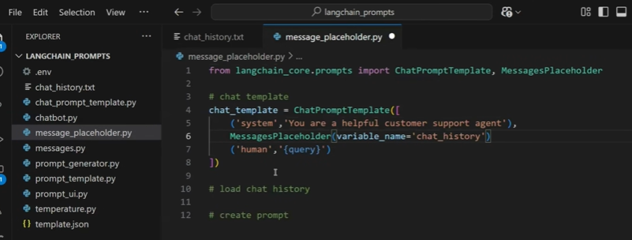
Load the chat history
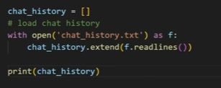
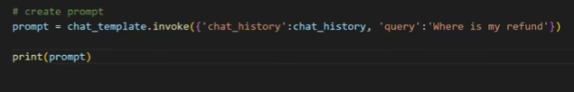

44. How Message Placeholder Works Conceptually
Inside Chat Prompt Template:
- You define a placeholder like {chat_history}
- This placeholder represents multiple messages
At runtime:
- you pass a list of messages
- LangChain expands it into the message list
- order and roles are preserved

45. Placement of Message Placeholder Matters
Correct structure:
- System message (defines role)
- Message placeholder (past conversation)
- Current human message
Why this order?
- System sets behavior
- History provides context
- Current query is interpreted correctly

46. Storing and Loading Chat History
In practice:
- chat history is stored externally
- could be a database
- could be a file (for demos)
Each stored line is converted into:
- HumanMessage
- AIMessage
This ensures:
- role clarity
- structured context

47. Injecting Chat History into the Prompt
At invocation time:
- chat history list is passed to {chat_history}
- current user query is passed to {query}
The final prompt becomes:
- system message
- entire past conversation
- current user message
Now the LLM has full conversational awareness.

48. Why This Is Critical for Production-Grade Chatbots
Without Message Placeholder:
- every query looks new
- follow-up questions fail
- user experience breaks
With Message Placeholder:
- long-term context is preserved
- answers become accurate
- chatbot feels “intelligent”
This is non-negotiable in real systems.

49. Industry Project Ideas (Only Where Relevant)
Project 1: Customer Support Refund Chatbot
- Uses Chat Prompt Template
- Uses Message Placeholder
- Stores chat history in DB
- Answers follow-up refund queries correctly

Project 2: Domain-Specific Expert Bot
- Dynamic system message (finance, health, legal)
- Dynamic user questions
- Context-aware follow-ups

Project 3: Session-Based AI Assistant
- Chat resumes after logout
- Past context loaded automatically
- Message Placeholder used for continuity

50. Final Summary of This Section
- Chat Prompt Template → dynamic multi-message prompts
- Required for multi-turn conversations
- Tuple-based message definitions are safer
- Message Placeholder → dynamic chat history injection
- Essential for real-world chatbots
- Foundation of memory, agents, and RAG pipelines

